# Practical 1

# Aim:- To develop a program for multi-client chat server using Socket

// RPC

//ChatClient.java

import java.net.*;

import java.io.*;

public class ChatClient {

  Socket soc;

  BufferedReader br, br1;

  PrintWriter out;

  String str;

  public ChatClient() // constructor

  {

    try {

      soc = new Socket(InetAddress.getLocalHost(), 9999);

      br = new BufferedReader(new InputStreamReader(System.in));

      out = new PrintWriter(soc.getOutputStream(), true);

      System.out.println("Chat Client Started");

      while (true) {

        str = br.readLine();

        out.println(str);

        new InnerClient();

      }

    } catch (Exception e) {

      e.printStackTrace();

    }

  }

  class InnerClient extends Thread // inside Chatclient class

  {

    String str1;

    InnerClient() {

      try {

        br1 = new BufferedReader(new InputStreamReader(soc.getInputStream()));

        start();

      } catch (Exception e) {

        e.printStackTrace();

      }

    }

    public void run() {

      try {

        while (true) {

          str1 = br1.readLine();

          System.out.println("Server says : " + str1);

        }

      } catch (Exception e) {

        e.printStackTrace();

      }

    }

  } // end of InnerClient class

  public static void main(String args[]) // method of outer class ChatClient

  {

    new ChatClient();

  }

}

//RPC

//ChatServer.java

import java.net.*;

import java.io.*;

public class ChatServer extends Thread {

  ServerSocket ss;

  Socket soc;

  BufferedReader br, br1;

  PrintWriter out;

  String str;

  public ChatServer() {

    try {

      ss = new ServerSocket(9999);

      soc = ss.accept();

      br = new BufferedReader(new InputStreamReader(soc.getInputStream()));

      // InputStreamReader ir=new InputStreamReader(soc.getInputStream());

      // br = new BufferedReader(ir);

      System.out.println("Chat Server Started");

      start();

      new InnerServer();

    } catch (Exception e) {

      e.printStackTrace();

    }

  } // end of ChatServer()

  public void run() {

    try {

      while (true) // the data coming client is displayed

      {

        str = br.readLine();

        System.out.println("Client says : " + str);

      }

    } catch (Exception e) {

      e.printStackTrace();

    }

  } // end of run()

  class InnerServer // inside ChatServer class

  // the data from server will be read from console and sent to client.

  {

    String str1;

    InnerServer() // constructor

    {

      try {

        br1 = new BufferedReader(new InputStreamReader(System.in));

        out = new PrintWriter(soc.getOutputStream(), true);

        while (true) // read the data from br1 and put in 'out'

        {

          // str1 = br1.readLine();

          // out.println(str1);

          out.println(br1.readLine());

        }

      } catch (Exception e) {

        e.printStackTrace();

      }

    }

  } // end of InnerSErver class

  public static void main(String args[]) // method of chatServer class

  {

    new ChatServer();

  }

}

**Output:-**

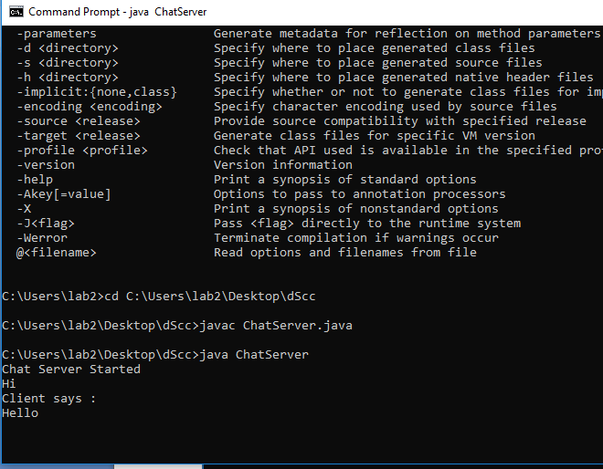

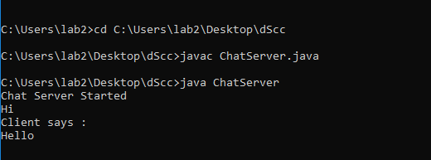

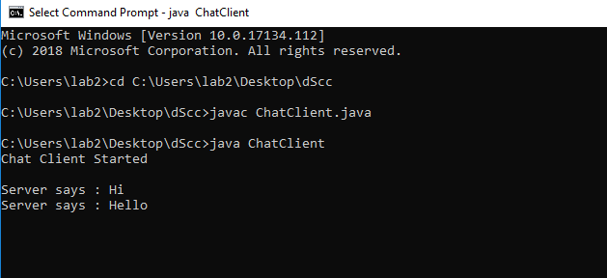

# Practical 2

# Aim:- To Implement a server calculator using RPC concept

//RPC Server

//To Implement a server calculator containing ADD(),MUL(),SUB()

import java.util.*;

import java.net.*;

class RPCServer {

  DatagramSocket ds;

  DatagramPacket dp;

  String str, methodName, result;

  int val1, val2;

  RPCServer() {

    try {

      ds = new DatagramSocket(1200);

      byte b[] = new byte[4096];

      // int a[]=new int[100];

      while (true) {

        dp = new DatagramPacket(b, b.length);

        ds.receive(dp);

        str = new String(dp.getData(), 0, dp.getLength()); // add 10 20

        if (str.equalsIgnoreCase("q")) {

          System.exit(1);

        } else {

          StringTokenizer st = new StringTokenizer(str, " ");

          int i = 0;

          while (st.hasMoreTokens()) {

            // String token=st.nextToken();

            methodName = st.nextToken(); // add

            val1 = Integer.parseInt(st.nextToken()); // 10

            val2 = Integer.parseInt(st.nextToken()); // 20

          }

        }

        System.out.println(str); // print add 10 20

        InetAddress ia = InetAddress.getLocalHost();

        if (methodName.equalsIgnoreCase("add"))

          result = "" + add(val1, val2);

        else if (methodName.equalsIgnoreCase("sub"))

          result = "" + sub(val1, val2);

        else if (methodName.equalsIgnoreCase("mul"))

          result = "" + mul(val1, val2);

        else if (methodName.equalsIgnoreCase("div"))

          result = "" + div(val1, val2);

        byte b1[] = result.getBytes(); // convert string data into byte

        DatagramSocket ds1 = new DatagramSocket();

        DatagramPacket dp1 = new DatagramPacket(b1, b1.length, InetAddress.getLocalHost(), 1300);

        System.out.println("result : " + result + "\n");

        ds1.send(dp1);

      }

    } catch (Exception e) {

      e.printStackTrace();

    }

  }

  public int add(int val1, int val2) {

    return val1 + val2;

  }

  public int sub(int val3, int val4) {

    return val3 - val4;

  }

  public int mul(int val3, int val4) {

    return val3 * val4;

  }

  public int div(int val3, int val4) {

    return val3 / val4;

  }

  public static void main(String[] args) {

    new RPCServer();

  }

}

//RPC Client

import java.io.*;

import java.net.*;

class RPCClient {

  RPCClient() {

    try {

      InetAddress ia = InetAddress.getLocalHost();

      DatagramSocket ds = new DatagramSocket();

      DatagramSocket ds1 = new DatagramSocket(1300);

      System.out.println("\nRPC Client\n");

      System.out.println("Enter method name and parameter like add 10 20\n");

      System.out.println("Press \'q\' to quit \n");

      while (true) {

        BufferedReader br = new BufferedReader(new InputStreamReader(System.in));

        String str = br.readLine();

        byte b[] = str.getBytes();

        DatagramPacket dp = new DatagramPacket(b, b.length, ia, 1200);

        ds.send(dp);

        dp = new DatagramPacket(b, b.length);

        ds1.receive(dp);

        String s = new String(dp.getData(), 0, dp.getLength());

        System.out.println("\nResult = " + s + "\n");

      }

    } catch (Exception e) {

      e.printStackTrace();

    }

  }

  public static void main(String[] args) {

    new RPCClient();

  }

}

# Output:-

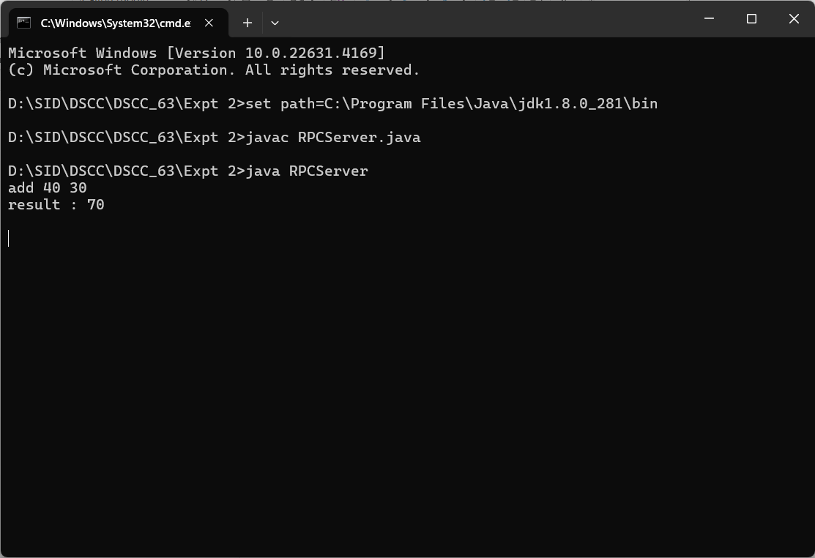

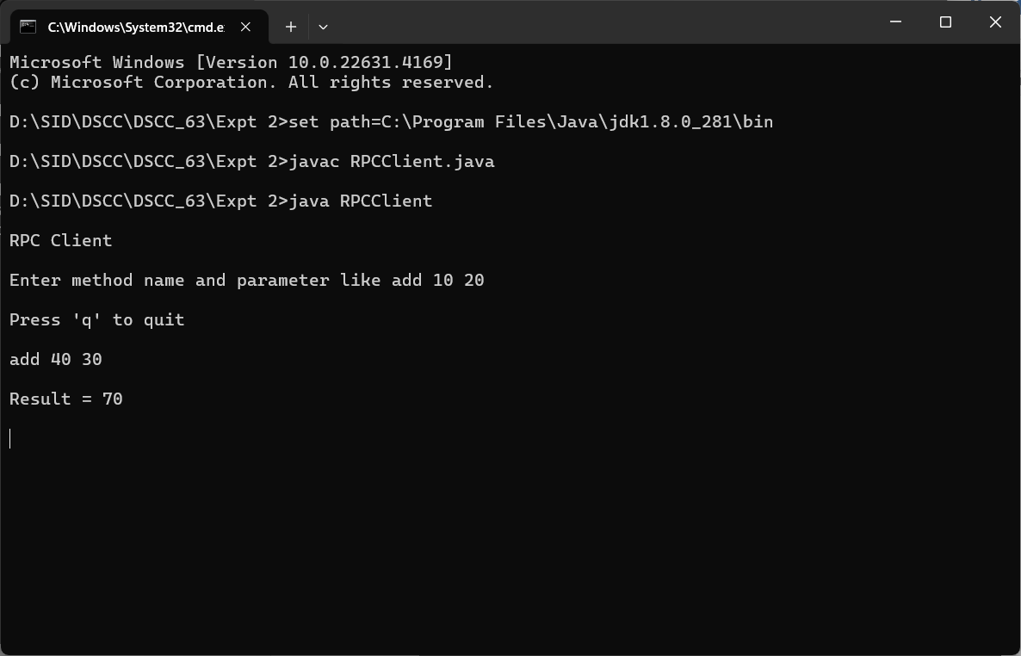

# Practical 3

# Aim:- To implement a Date Time Server using RPC concept.(Make use of datagram)

//To Implement a Date time server containing date() and time() procedure.

import java.util.*;

import java.net.*;

import java.text.SimpleDateFormat;

class RPCServer1 {

  DatagramSocket ds;

  DatagramPacket dp;

  String str, methodName, result;

  int val1, val2;

  RPCServer1() {

    try {

      ds = new DatagramSocket(1200);

      byte b[] = new byte[4096];

      while (true) {

        dp = new DatagramPacket(b, b.length);

        ds.receive(dp);

        str = new String(dp.getData(), 0, dp.getLength());

        if (str.equalsIgnoreCase("q")) {

          System.exit(1);

        } else {

          StringTokenizer st = new StringTokenizer(str, " ");

          int i = 0;

          while (st.hasMoreTokens()) {

            methodName = st.nextToken();

          }

        }

        Calendar c = Calendar.getInstance();

        SimpleDateFormat dateFormat = new SimpleDateFormat("dd/MM/yyyy");

        Date d = c.getTime();

        InetAddress ia = InetAddress.getLocalHost();

        if (methodName.equalsIgnoreCase("date"))

          result = "" + dateFormat.format(d);

        else if (methodName.equalsIgnoreCase("time"))

          result = "" + d.getHours() + " : " + d.getMinutes() + " : " + d.getSeconds();

        byte b1[] = result.getBytes();

        DatagramSocket ds1 = new DatagramSocket();

        DatagramPacket dp1 = new DatagramPacket(b1, b1.length, InetAddress.getLocalHost(), 1300);

        System.out.println("result : " + result + "\n");

        ds1.send(dp1);

      }

    } catch (Exception e) {

      e.printStackTrace();

    }

  }

  public static void main(String[] args) {

    new RPCServer1();

  }

}

//RPC client1

import java.io.*;

import java.net.*;

class RPCClient1 {

  RPCClient1() {

    try {

      InetAddress ia = InetAddress.getLocalHost();

      DatagramSocket ds = new DatagramSocket();

      byte b1[] = new byte[50];

      DatagramSocket ds1 = new DatagramSocket(1300);

      System.out.println("\nRPC Client\n");

      while (true) {

        BufferedReader br = new BufferedReader(new InputStreamReader(System.in));

        String str = br.readLine();

        byte b[] = str.getBytes();

        DatagramPacket dp = new DatagramPacket(b, b.length, ia, 1200);

        ds.send(dp);

        if (str.equalsIgnoreCase("q")) {

          System.out.println("server exited...");

          System.exit(1);

        }

        dp = new DatagramPacket(b1, b1.length);

        ds1.receive(dp);

        String s = new String(dp.getData(), 0, dp.getLength());

        System.out.println("\n Result = " + s);

      }

    } catch (Exception e) {

      e.printStackTrace();

    }

  }

  public static void main(String[] args) {

    new RPCClient1();

  }

}

## Output:-

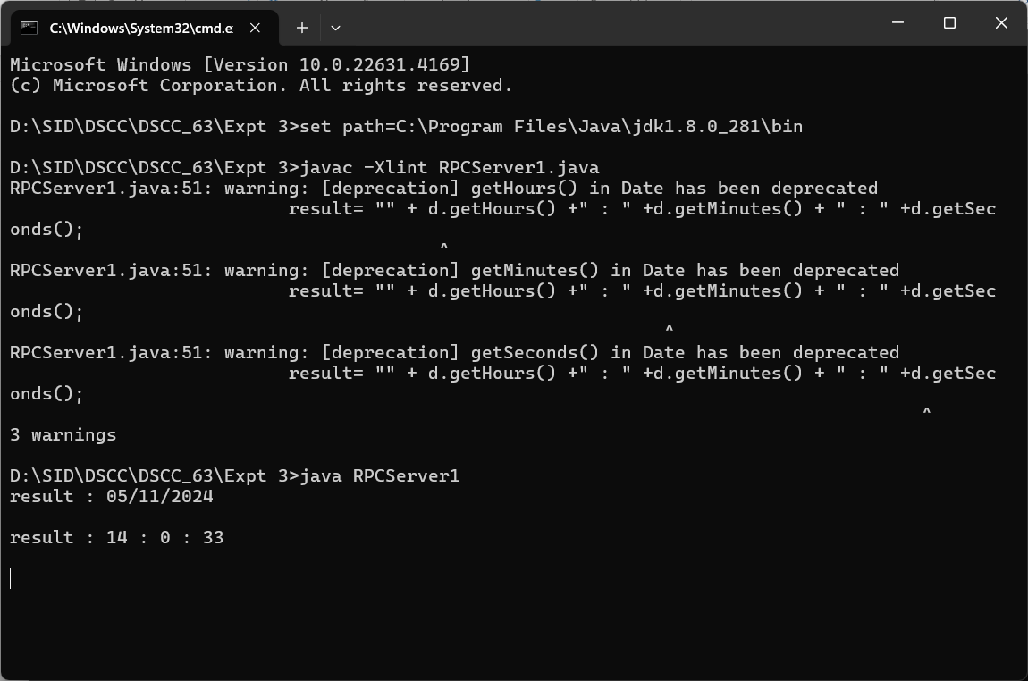

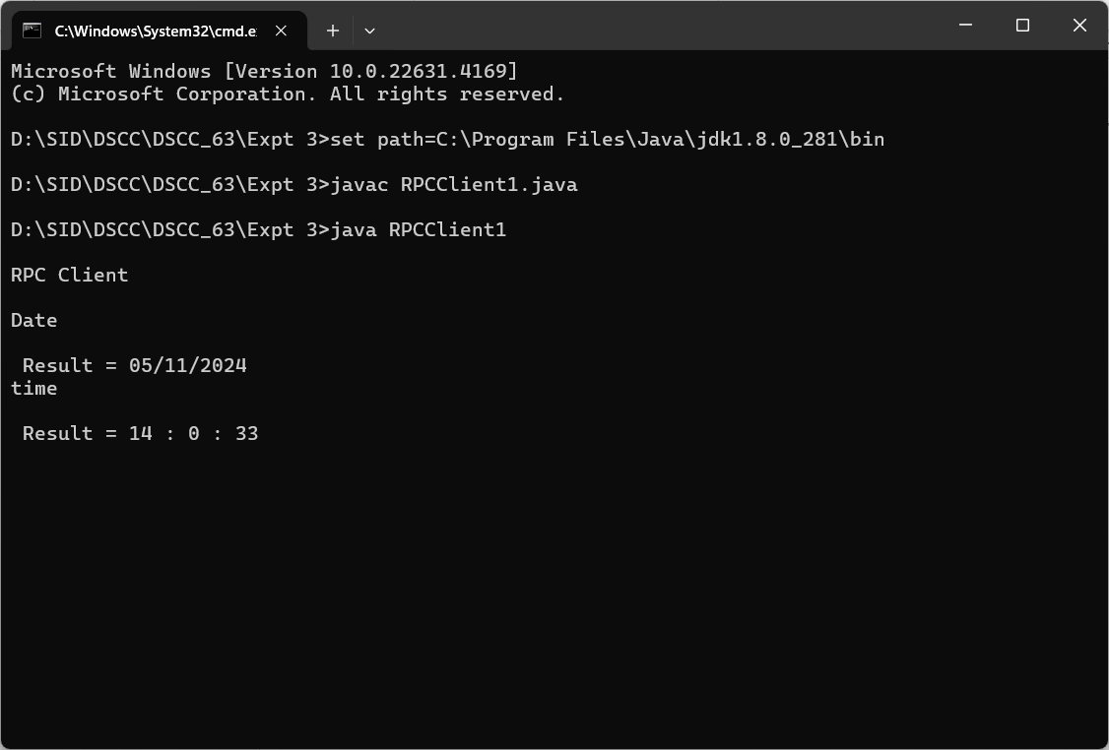

# Practical 4

# Aim:- To retrieve day, time and date function from server to client. This program should display server day, time and date.(use concept of JDBC and RMI for accessing multiple data access objects)

// DateClient.java

import java.rmi.*;

public class DateClient {

  public static void main(String[] args) {

    try {

      String url = "rmi://127.0.0.1/DServer";

      IDate intf = (IDate) Naming.lookup(url);

      // IDate intf=(IDate)Naming.lookup("rmi://127.0.0.1/DateServer");

      System.out.println("The Date On Server is: " + intf.getDate());

    } catch (Exception e) {

      e.printStackTrace();

    }

  }

}

// DateServer.java

import java.rmi.*;

public class DateServer {

    public static void main(String[] args) {

        try {

            DateImpl di = new DateImpl();

            Naming.rebind("DServer", di);

            System.out.println("Date Server is Ready");

        } catch (Exception e) {

            e.printStackTrace();

        }

    }

}

// IDate.java

import java.rmi.*;

public interface IDate extends Remote {

  String getDate() throws RemoteException;

}

// DateImpl.java

import java.rmi.*;

import java.rmi.server.*;

import java.util.*;

public class DateImpl extends UnicastRemoteObject implements IDate {

  public DateImpl() throws RemoteException {

  }

  public String getDate() {

    Date d = new Date();

    return (d.toString());

  }

}

## Output:-

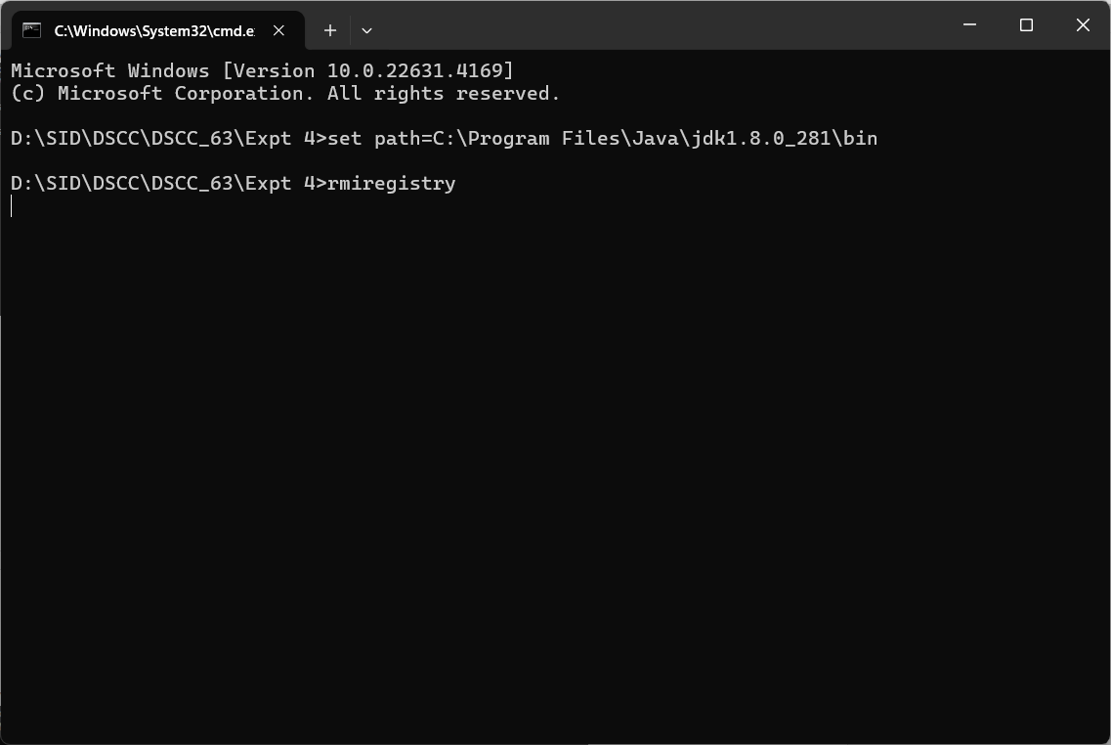

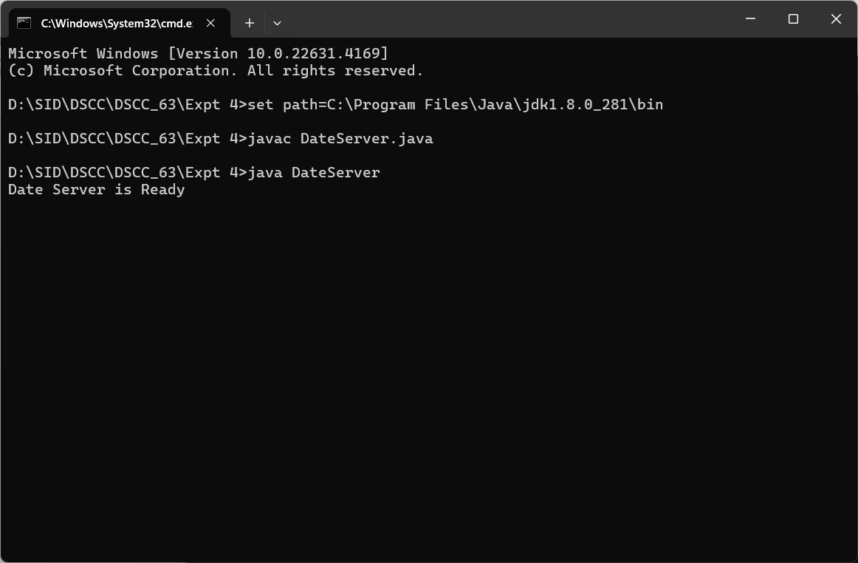

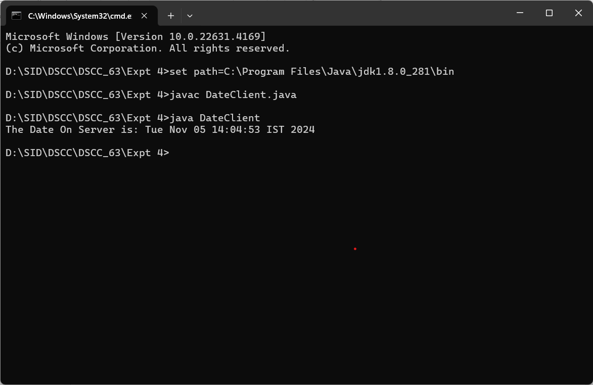

# Practical 5

# Aim:- The client should provide an equation to the server through an interface. The server will solve the expression given by the client.

// clientEqSolve.java

import java.io.*;

import java.net.*;

import java.rmi.*;

public class clientEqSolve {

   public static void main(String[] args) {

      try {

         int num1, num2, res = 0, choice;

         intfEqSolve object = (intfEqSolve) Naming.lookup("hello");

         BufferedReader br = new BufferedReader(new InputStreamReader(System.in));

         System.out.println("Equations:-");

         System.out.println("1.(a-b)2");

         System.out.println("2.(a+b)2");

         System.out.println("3.(a-b)3");

         System.out.println("4.(a+b)3");

         System.out.println("Choose the equation:");

         choice = Integer.parseInt(br.readLine());

         System.out.println("Enter the value of a and b");

         num1 = Integer.parseInt(br.readLine());

         num2 = Integer.parseInt(br.readLine());

         switch (choice) {

            case 1:

               res = object.solveEq1(num1, num2);

               break;

            case 2:

               res = object.solveEq2(num1, num2);

               break;

            case 3:

               res = object.solveEq3(num1, num2);

               break;

            case 4:

               res = object.solveEq4(num1, num2);

               break;

            default:

               System.out.println("Invalid option");

               break;

         }

         System.out.println("the answer is" + res);

      } catch (Exception e) {

         System.out.println("Exception:" + e);

      }

   }

}

// serverEqSolve.java

import java.io.*;

import java.net.*;

import java.rmi.*;

public class serverEqSolve {

   public static void main(String[] args) {

      try {

         implEqSolve obj = new implEqSolve();

         Naming.rebind("hello", obj);

      } catch (Exception e) {

         System.out.println(e);

      }

   }

}

// implEqSolve.java

import java.rmi.*;

import java.rmi.server.*;

public class implEqSolve extends UnicastRemoteObject implements intfEqSolve {

   public implEqSolve() throws RemoteException {

   }

   public int solveEq1(int a, int b) throws RemoteException {

      int ans = (a * a) - (2 * a * b) + (b * b);

      return ans;

   }

   public int solveEq2(int a, int b) throws RemoteException {

      int ans = (a * a) + (2 * a * b) + (b * b);

      return ans;

   }

   public int solveEq3(int a, int b) throws RemoteException {

      int ans = (a * a * a) - (3 * a * a * b) + (3 * a * b * b) - (b * b * b);

      return ans;

   }

   public int solveEq4(int a, int b) throws RemoteException {

      int ans = (a * a * a) + (3 * a * a * b) + (3 * a * b * b) + (b * b * b);

      return ans;

   }

}

// intfEqSolve.java

import java.rmi.*;

public interface intfEqSolve extends Remote {

    public int solveEq1(int a, int b) throws RemoteException;

    public int solveEq2(int a, int b) throws RemoteException;

    public int solveEq3(int a, int b) throws RemoteException;

    public int solveEq4(int a, int b) throws RemoteException;

}

**Output:-**

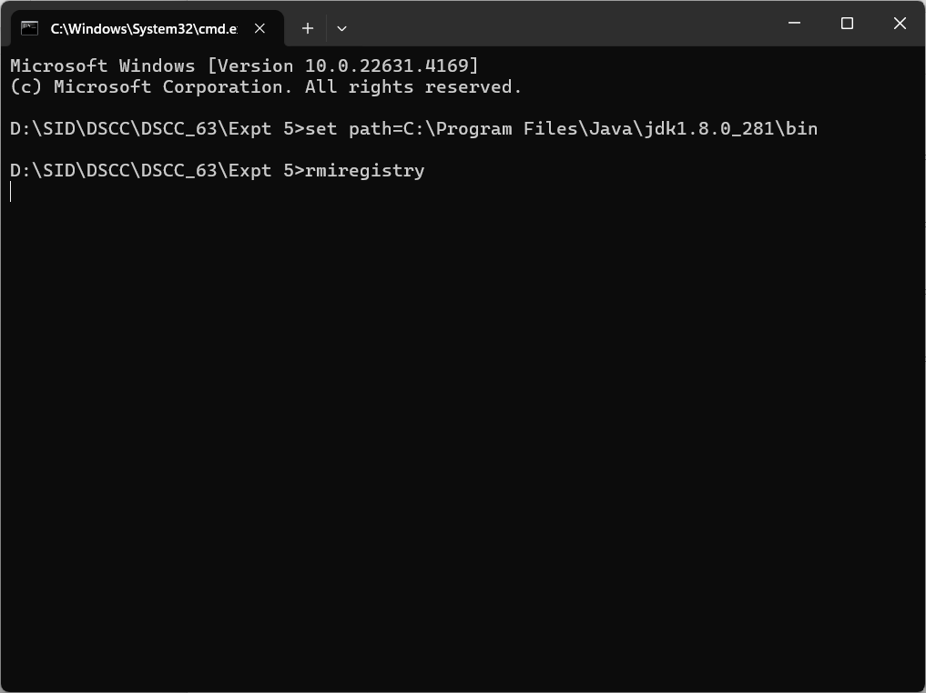

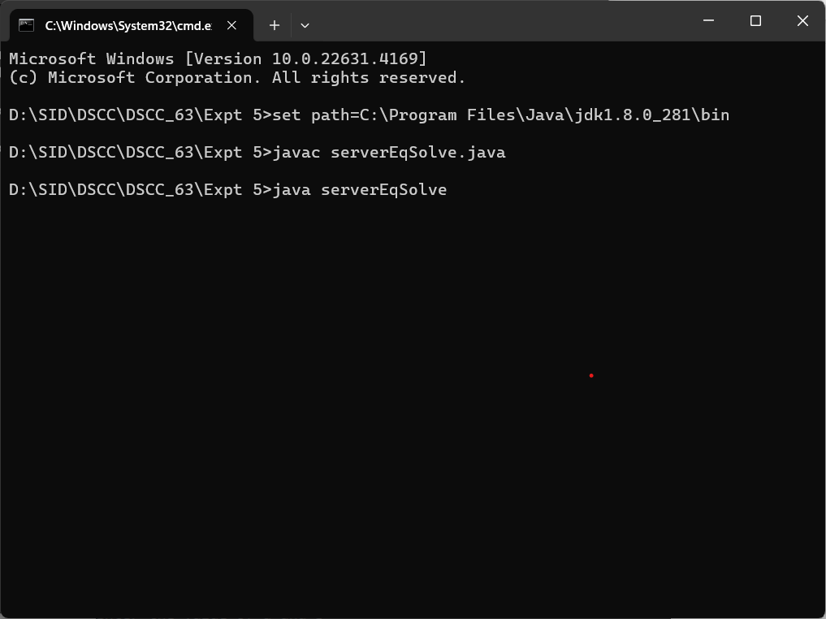

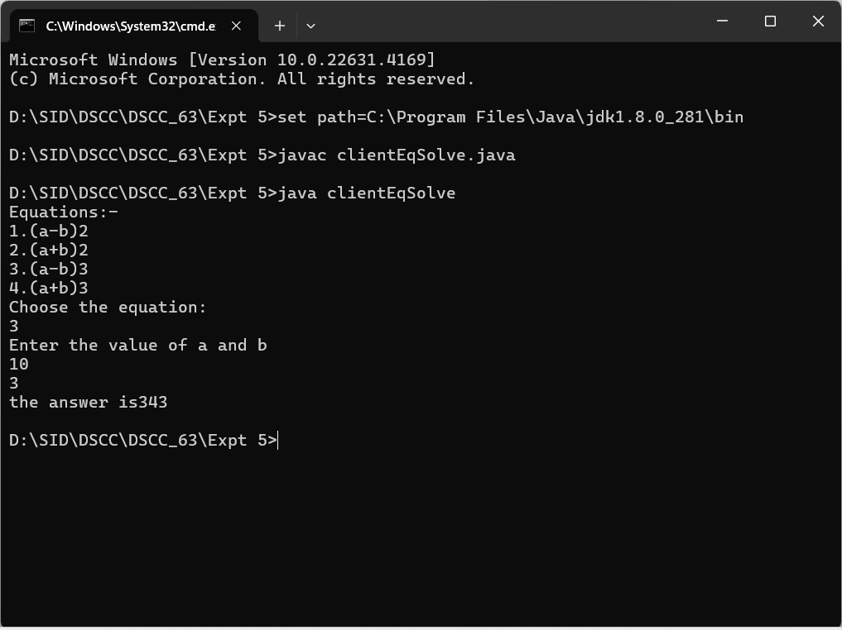

# Practical 6

# Aim:- Using MySQL create Library database. Create table Book(Book_id,Book_name,Book_author)and retrieve the book information from Library database using Remote Object Communication concept.

//DBClient.java for Practical 6 (Using Only one .accdb file)(same for mysql odbc connection)

import java.rmi.*;

import java.io.*;

public class DBClient_P6 {

  public static void main(String[] args) {

    String sql = "", res = "";

    try

    {

      BufferedReader br = new BufferedReader(new InputStreamReader(System.in));

      System.out.println("\n*** Books Table ***");

      sql = "select * from Book";

      String url = "rmi://127.0.0.1/DBServer";

      IDb id = (IDb) Naming.lookup(url);

      res = id.getData(sql, "LibraryDB");

      System.out.println("\n-----------------------------------------------------------");

      System.out.print(res);

      System.out.println("-----------------------------------------------------------");

    } // end of try

    catch (Exception e)

    {

      e.printStackTrace();

    }

  }

}

//DBServer.java

import java.rmi.*;

public class DBServer {

  public static void main(String[] args) {

    try {

      DBImpl di = new DBImpl();

      Naming.rebind("rmi://127.0.0.1/DBServer", di);

      System.out.println("Server Registered.");

    } catch (Exception e1) {

      e1.printStackTrace();

    }

  }

}

//DBImpl.java

import java.rmi.*;

import java.rmi.server.*;

import java.sql.*;

public class DBImpl extends UnicastRemoteObject implements IDb {

  String str, str1;

  public DBImpl() throws RemoteException {

  }

  public String getData(String sql, String dsn) {

    String URL = "jdbc:odbc:" + dsn;

    try {

      Class.forName("sun.jdbc.odbc.JdbcOdbcDriver");

      Connection con = DriverManager.getConnection(URL);

      Statement s = con.createStatement();

      ResultSet rs = s.executeQuery(sql);

      ResultSetMetaData rsmd = rs.getMetaData();

      str = "";

      str1 = "";

      for (int i = 1; i <= rsmd.getColumnCount(); i++) {

        str1 = str1 + rsmd.getColumnName(i) + "\t";

      }

      System.out.println();

      while (rs.next()) {

        for (int i = 1; i <= rsmd.getColumnCount(); i++) {

          str = str + rs.getString(i) + "\t";

        }

        str = str + "\n";

      }

    } catch (Exception e) {

      e.printStackTrace();

    }

    return (str1 + "\n" + str);

  }

}

//IDb.java

import java.rmi.*;

public interface IDb extends Remote {

  public String getData(String s, String db) throws RemoteException;

}

**Output:-**

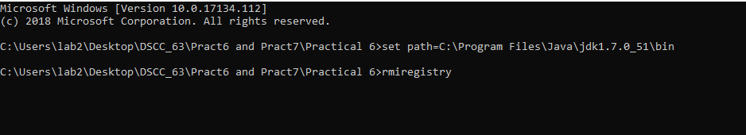

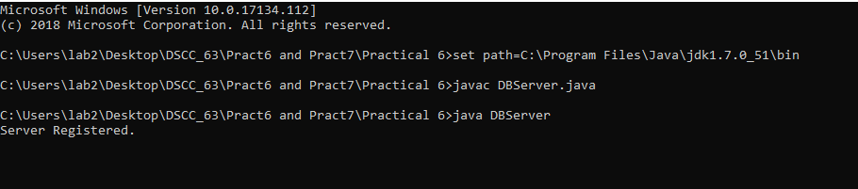

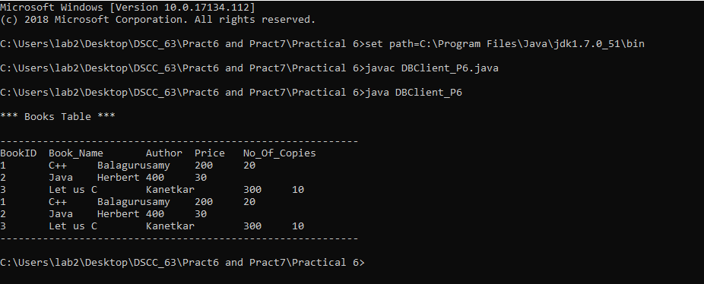

# Practical 7

**Aim:- Using MySQL create Elecrtic_Bill database. Create table Bill (consumer_name, bill_due_date, bill_amount) and retrieve the Bill information from the Elecrtic_Bill database using Remote Object Communication concept.**

//DBClient.java for Practical 7 (Using Only one .accdb file)(same for mysql odbc connection)

import java.rmi.*;

import java.io.*;

public class DBClient_P7 {

  public static void main(String[] args) {

    String sql = "", res = "";

    try

    {

      BufferedReader br = new BufferedReader(new InputStreamReader(System.in));

      System.out.println("\n*** Bill Table ***");

      sql = "select * from Bill";

      String url = "rmi://127.0.0.1/DBServer";

      IDb id = (IDb) Naming.lookup(url);

      res = id.getData(sql, "MtnlDB");

      System.out.println("\n-----------------------------------------------------------");

      System.out.print(res);

      System.out.println("-----------------------------------------------------------");

    } // end of try

    catch (Exception e)

    {

      e.printStackTrace();

    }

  }

}

// DBServer.java

import java.rmi.*;

public class DBServer {

  public static void main(String[] args) {

    try {

      DBImpl di = new DBImpl();

      Naming.rebind("rmi://127.0.0.1/DBServer", di);

      System.out.println("Server Registered.");

    } catch (Exception e1) {

      e1.printStackTrace();

    }

  }

}

//DBImpl.java

import java.rmi.*;

import java.rmi.server.*;

import java.sql.*;

public class DBImpl extends UnicastRemoteObject implements IDb {

  String str, str1;

  public DBImpl() throws RemoteException {

  }

  public String getData(String sql, String dsn) {

    String URL = "jdbc:odbc:" + dsn;

    try {

      Class.forName("sun.jdbc.odbc.JdbcOdbcDriver");

      Connection con = DriverManager.getConnection(URL);

      Statement s = con.createStatement();

      ResultSet rs = s.executeQuery(sql);

      ResultSetMetaData rsmd = rs.getMetaData();

      str = "";

      str1 = "";

      for (int i = 1; i <= rsmd.getColumnCount(); i++) {

        str1 = str1 + rsmd.getColumnName(i) + "\t";

      }

      System.out.println();

      while (rs.next()) {

        for (int i = 1; i <= rsmd.getColumnCount(); i++) {

          str = str + rs.getString(i) + "\t";

        }

        str = str + "\n";

      }

    } catch (Exception e) {

      e.printStackTrace();

    }

    return (str1 + "\n" + str);

  }

}

//IDb.java

import java.rmi.*;

public interface IDb extends Remote {

  public String getData(String s, String db) throws RemoteException;

}

**Output:-**

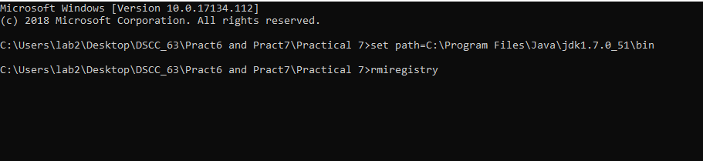

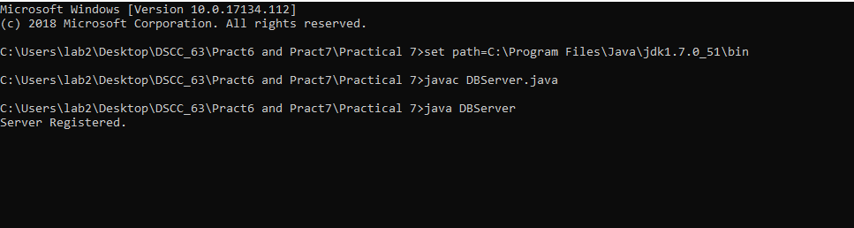

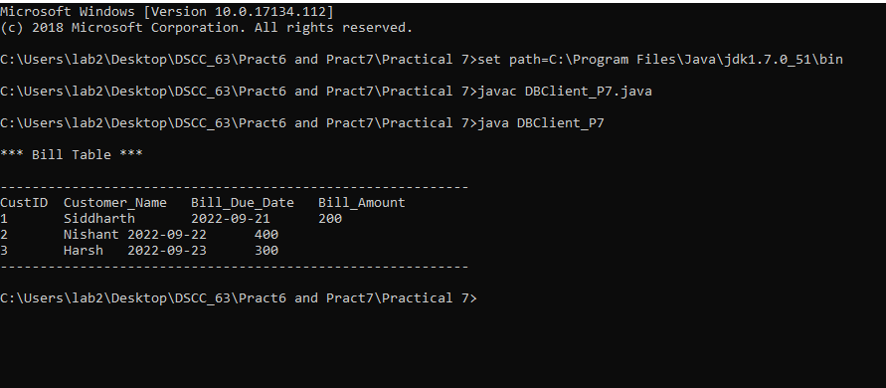

# Practical 8

**Aim:- Implementation of mutual exclusion using Token ring algorithm.**

//TokenServer

import java.net.*;

import java.io.*;

class TokenServer {

  public static DatagramSocket ds;

  public static DatagramPacket dp;

  public static void main(String[] args) throws Exception {

    try {

      ds = new DatagramSocket(1000); // ds is the object of DatagramSocket at port 1000

      while (true) {

        byte buff[] = new byte[1024];

        // data coming from client is in byte form. This data is stored in buff array

        // this data is received at server through ds

        dp = new DatagramPacket(buff, buff.length);

        ds.receive(dp);

        // data in byte form is converted in string form

        String str = new String(dp.getData(), 0, dp.getLength());

        // the data received from client is display at server

        System.out.println("Message from " + str);

      }

    } catch (Exception e) {

      e.printStackTrace();

    }

  }

}

//TokenClient1

import java.net.*;

import java.io.*;

class TokenClient1 {

  public static DatagramSocket ds;

  public static DatagramPacket dp;

  public static BufferedReader br;

  static int cp = 100;

  public static void main(String[] args) throws Exception {

    boolean hasToken;

    try {

      ds = new DatagramSocket(100);

    } catch (Exception e) {

      e.printStackTrace();

    }

    hasToken = true;

    while (true) {

      if (hasToken == true) {

        System.out.println("Do you want to enter data...(yes/no):");

        br = new BufferedReader(new InputStreamReader(System.in));

        String ans = br.readLine();

        if (ans.equalsIgnoreCase("yes")) {

          System.out.println("ready to send……….");

          System.out.println("sending……………..");

          System.out.println("Enter the data            ");

          br = new BufferedReader(new InputStreamReader(System.in));

          String str = "Client-1===> " + br.readLine();

          byte buff[] = new byte[1024];

          buff = str.getBytes();

          ds.send(new DatagramPacket(buff, buff.length, InetAddress.getLocalHost(),

              1000));

          System.out.println("now sending……….");

        } else if (ans.equalsIgnoreCase("no")) {

          System.out.println("I am  in busy state now……..");

          // sending msg to client-2

          String msg = "Token";

          byte bf1[] = new byte[1024];

          bf1 = msg.getBytes();

          ds.send(new DatagramPacket(bf1, bf1.length,

              InetAddress.getLocalHost(), 200));

          hasToken = false;

          // receiving msg from client-2

          byte bf2[] = new byte[1024];

          ds.receive(dp = new DatagramPacket(bf2, bf2.length));

          String clientmsg = new String(dp.getData(), 0, dp.getLength());

          System.out.println("The data passed from client2 is " + clientmsg);

          if (clientmsg.equals("Token"))

            hasToken = true;

          System.out.println("I am leaving busy state");

        }

      } else {

        System.out.println("Entering in receive mode.");

        byte bf[] = new byte[1024];

        ds.receive(dp = new DatagramPacket(bf, bf.length));

        String clientmsg1 = new String(dp.getData(), 0, dp.getLength());

        System.out.println("The data passed from Client1 is " + clientmsg1);

        if (clientmsg1.equals("Token"))

          ;

        {

          hasToken = true;

        }

      }

    }

  }

}

//Token client 2:

import java.net.*;

import java.io.*;

class TokenClient2 {

  static DatagramSocket ds;

  static DatagramPacket dp;

  static BufferedReader br;

  public static void main(String[] args) throws Exception {

    try {

      ds = new DatagramSocket(200);

    } catch (Exception e) {

      e.printStackTrace();

    }

    boolean hasToken = true;

    while (true) {

      // System.out.println("Entering if");

      if (hasToken == true) {

        System.out.println("Do you want to enter data(Yes/No):");

        br = new BufferedReader(new InputStreamReader(System.in));

        String str = br.readLine();

        if (str.equalsIgnoreCase("yes")) {

          System.out.println("Enter Data; ");

          br = new BufferedReader(new InputStreamReader(System.in));

          String msg = "Client-2===>" + br.readLine();

          byte bf1[] = new byte[1024];

          bf1 = msg.getBytes();

          ds.send(new DatagramPacket(bf1, bf1.length, InetAddress.getLocalHost(), 1000));

          System.out.println("Data sent");

        } else {

          // send to client 1.

          String clientmsg = "Token";

          byte bf2[] = new byte[1024];

          bf2 = clientmsg.getBytes();

          ds.send(new DatagramPacket(bf2, bf2.length, InetAddress.getLocalHost(), 100));

          hasToken = false;

        }

      } else {

        try {

          byte buff[] = new byte[1024];

          System.out.println("Entering in waiting/receiving mode.");

          ds.receive(dp = new DatagramPacket(buff, buff.length));

          String clientmsg1 = new String(dp.getData(), 0, dp.getLength());

          System.out.println("The data is " + clientmsg1);

          if (clientmsg1.equals("Token"))

            hasToken = true;

        } catch (Exception e) {

          e.printStackTrace();

        }

      }

    }

  }

}

**Output:-**

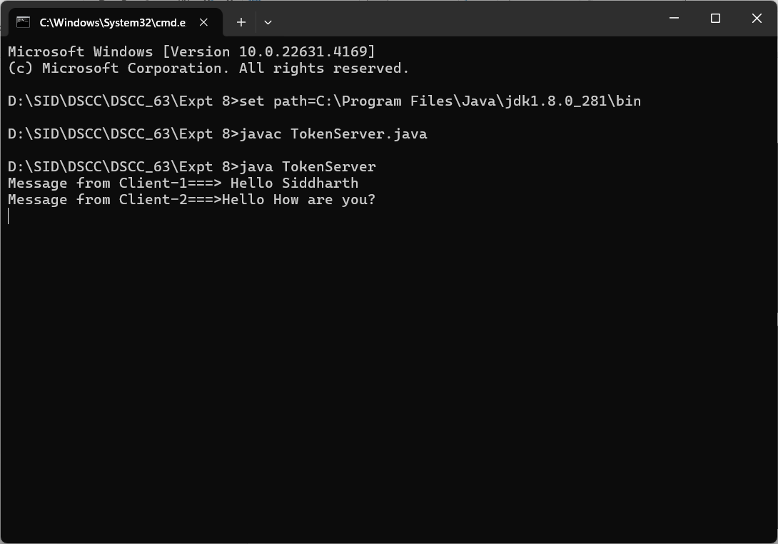

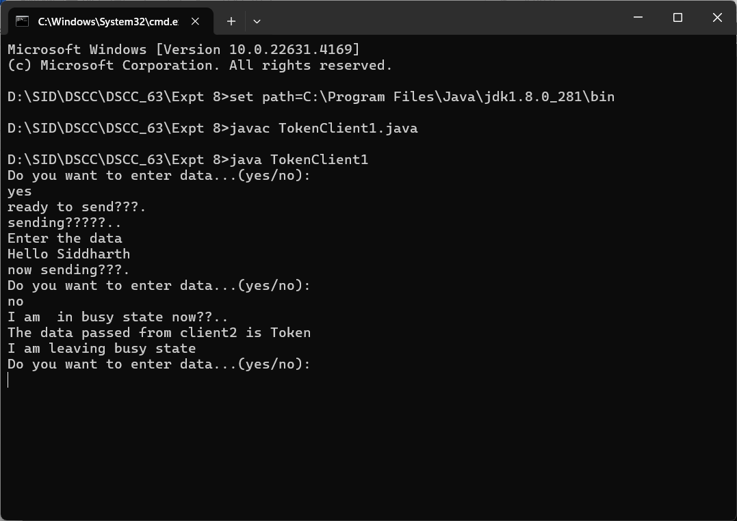

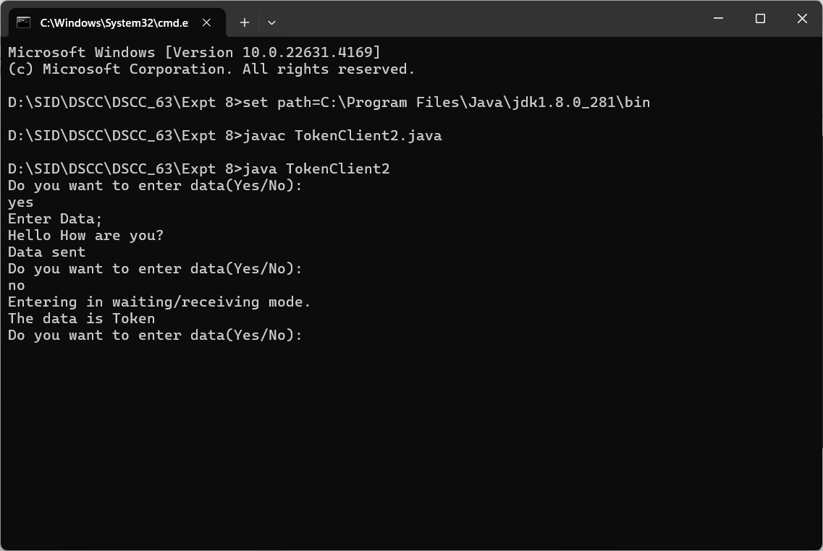

Practical 9

Aim:- **To study and Implement Storage as a Service using its Own Cloud/ AWS S3, Glaciers/and Azure Storage.**

# Theory:

Storage as a service (STaaS) Storage as a service (STaaS) is a cloud business model in which a company leases or rents its storage infrastructure to another company or individuals to store data. Small companies and individuals often find this to be a convenient methodology for managing backups, and providing cost savings in personnel, hardware and physical space. As an alternative to storing magnetic tapes offsite in a vault, IT administrators are meeting their storage and backup needs by service level agreements (SLAs) with an SaaS provider, usually on a cost-per-gigabyte-stored and cost-per-data-transferred basis. The client transfers the data meant for storage to the service provider on a set schedule over the SaaS provider’s wide area network or over the Internet

# Advantages of STaaS

1. Storage costs Personnel, hardware and physical storage space expenses are reduced.
2. Disaster recovery Having multiple copies of data stored in different locations can better enable disaster recovery measures.
3. Scalability With most public cloud services, users only pay for the resources that they use.
4. Syncing Files can be automatically synced across multiple devices.
5. Security can be both an advantage and a disadvantage, as security methods may change per vendor. Data tends to be encrypted during transmission and while at rest.

# Disadvantages of STaaS

1. Security Users may end up transferring business-sensitive or mission-critical data to the cloud, which makes it important to choose a service provider that's reliable.
2. Potential storage costs If bandwidth limitations are exceeded, these could be expensive.
3. Potential downtimes Vendors may go through periods of downtime where the service is not available, which can be trouble for mission-critical data.
4. Limited customization Since the cloud infrastructure is owned and managed by the service provider, it is less customizable.
5. Potential for vendor lock-in It may be difficult to migrate from one service to another

# Software As Service using Google Drive

# Agenda

* Introduction to Google Drive
* Share with Google Drive
* My Drive
* Shared Google Drives
* Google Drive tools and options

# Introduction to Google Drive

Google Drive is Google Software as a Service as part of productivity suite Google Drive helps you sharing files safely with your peers, collaborate real-time and organize your files quickly and easily.

## With Google Drive you can:

* Create, add, or upload a file with a single button.
* Find and add files shared with you more easily.
* Drag-and-drop files and folders just like you do on your desktop.
* Access your files from any of your devices.

## Common Use Cases for Google Drive

* Access and edit your work files anywhere
* Share files with a team or department
* Store and search all of your company's files
* Collaborate with co-workers and partners in real-time

# My Drive

* My drive represents content that you own & content that you have permission to access
* When content is created in my drive the creator owns the content

## Owners can

* Move files and folders
* Add collaborators with edit comment or view permission
* Share a link to a file or folder d
* Delete content and restore it from the trash

## Share Google Drive

* Share drives are shared spaces in Google drive for sharing content with a team instead
* The content in a shared drive is owned by the team
* As people join and leave a team the content remains accessible in the shared drive
* Share drives have more collaborator roles and more options for granular access to files and folders

## Common Use Cases for Shared Drive

* Project file repositories
* Employee onboarding
* Training resources
* Scenarios where the entire company needs access to the same file

## Share Google Drive - Permissions

Shared drive permissions are more granular than the options available when sharing files or folders from my drive

## Permissions for Shared Driver

* Manger: have full access to the shared drive and can change its settings along with managing members and deletion of content
* Content managers can perform most file level tasks except permanently delete content
* Contributors can create have permission to create new files and folders but not organize content
* Commenters can only provide comments
* Viewers can only view content

Each shared drive has its own trash and content is permanently removed from the trash after 30 days to restore a deleted file or folder

# Google Drive tools and options

Google drive offers several additional tools add-ons and options that can be enabled to help meet your needs

Offline viewing drive: it's possible to work in Google drive without an active internet connection to make your Google docs sheets and slides available offline on your device. This is done by installing a Google drive offline extension to the browser. All the selected files can available for offline and any changes made to the file while offline will be sync when the internet is restored.

Google drive file stream: allows you to work from your desktop with files stored in the cloud the files are available on demand which means they don't require space on your device's storage nor do they require an enormous amount of bandwidth or download time this feature allows you to choose which files and folders are stored for offline access there are drive file stream applications for Microsoft windows and mac os. Drive file stream also supports real-time presence when editing Microsoft office files

Google workspace marketplace: an online store for applications that work with Google workspace for example Google docs doesn't have a built-in mail merge feature but several apps in the Google workspace marketplace can enable mail merge in Google docs there are add-ons related to productivity communication accounting legal marketing task management and many more

# Practical 10

# Aim: Study and implementation of Identity Management

**Procedure**:

Step1: Open the following link <https://aws.amazon.com/>

Step2: Go to my Account-> AWS management console

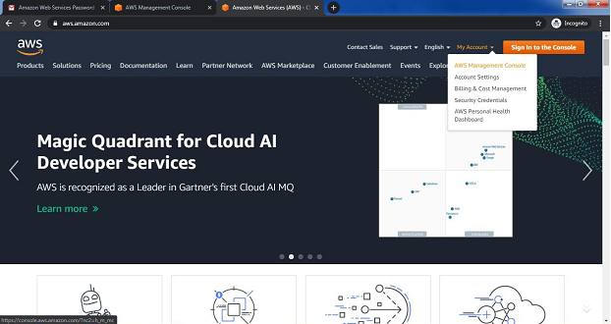

Step3: click on Create new user AWS account

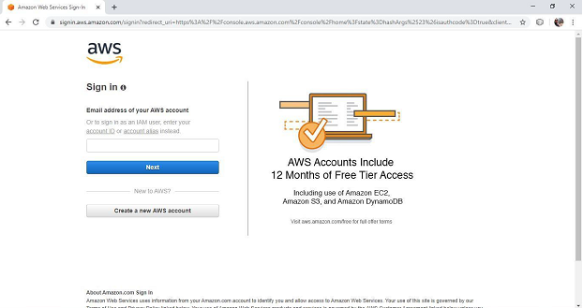

Step4: Fill all the details and click on Continue

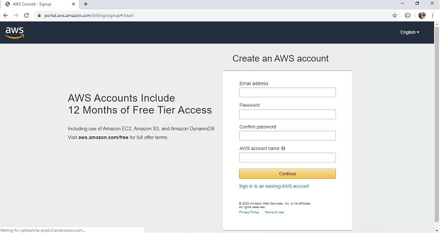

Step5: Fill your contact number and Home address and click on ***create account and continue***

Step6: Now most curtail step AWS will ask for credit card and debit card details. You have to close the browser

Step7: now again open the link <https://aws.amazon.com/>

Step8: Go to my Account->AWS Management console

Enter your ID and click on next, After that enter password and click on sign in

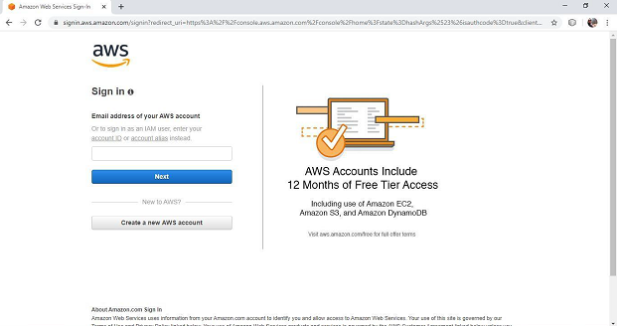

Step 9: you will get the following screen

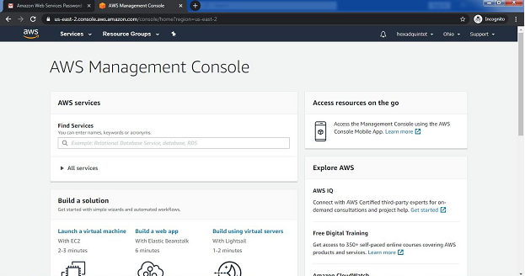

Step 10: Go to My Security credential

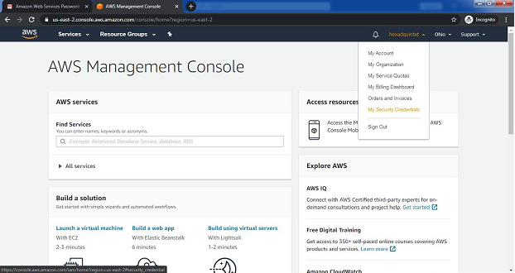

Step 11: now click on user

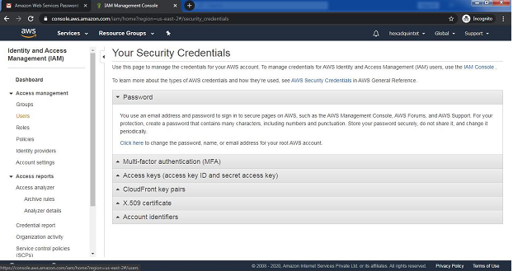

Step 12:Click on add user

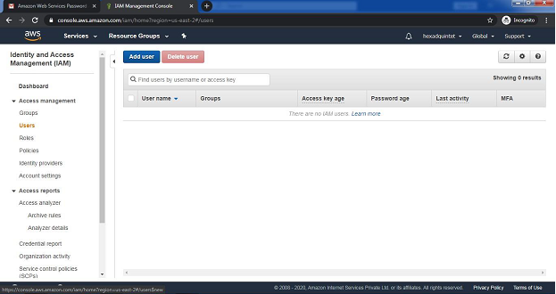

Step 13:Provide the user name and check the check box in front of ***programmatic access*** and ***AWS Management console Access*** and enter the password for new user Click on ***custom password*** and click on next permission

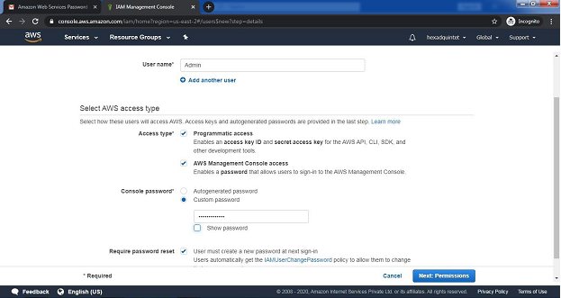

Step 14: click on create Group

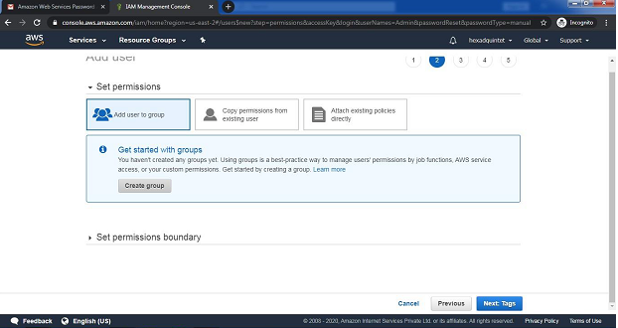

Step15:fill the information and click on Create Group

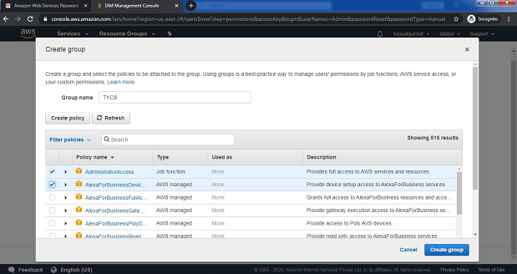

Step16:click on next tag leave blank , again click on next review leave as it is and click on create user



Step 17: click on close

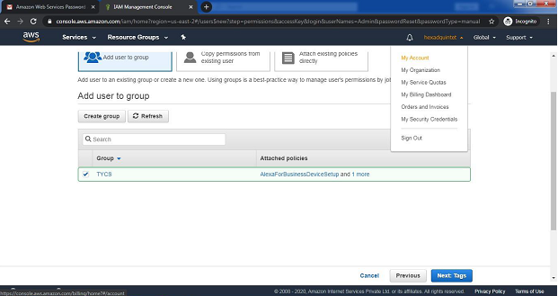

And COPY Account ID



Now logout the admin account and try to login as user(newly created) .

Step 18: again Go to my Account->AWS Management console

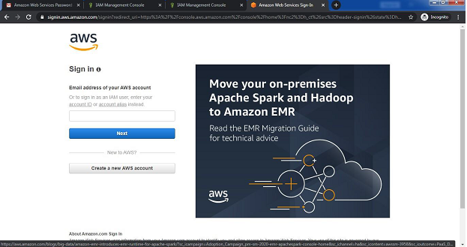

Click on next Provide the Account ID username and password and click on sign in It will ask you to change the password which is been set by administrator

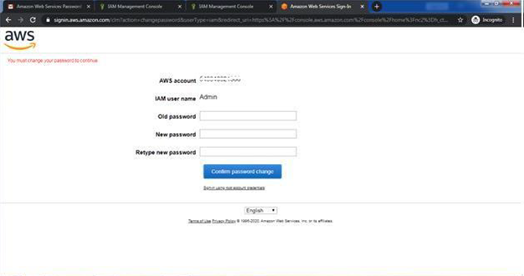

Yow will redirect to home screen

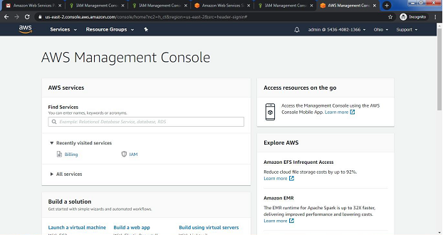

**Conclusion:** Hence we have studied the concept and implementation of identity management using amazon aws.

# Practical 11

# Aim : Develop application for Microsoft Azure

Step 1: To develop an application for Windows Azure on Visual Studio 2019, install the Visual Studio 2019.

Step2:•Open Visual Studio 2019

• Click on create new project

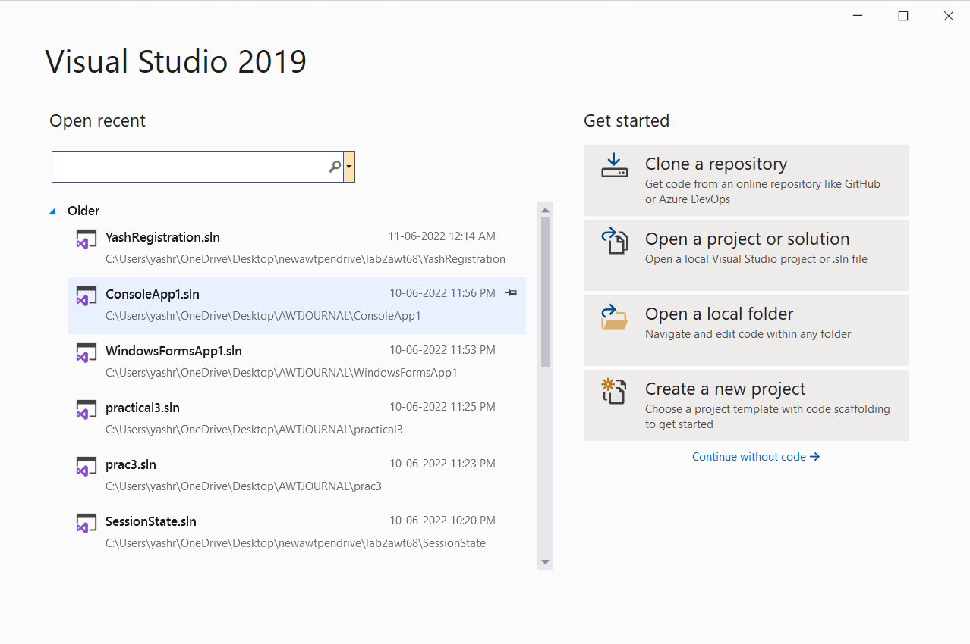

• After clicking on Create new project, a New Project Window will open type Azure cloud service in search box

Incase you don’t get Azure cloud service(classic) go to installer and install Azure development

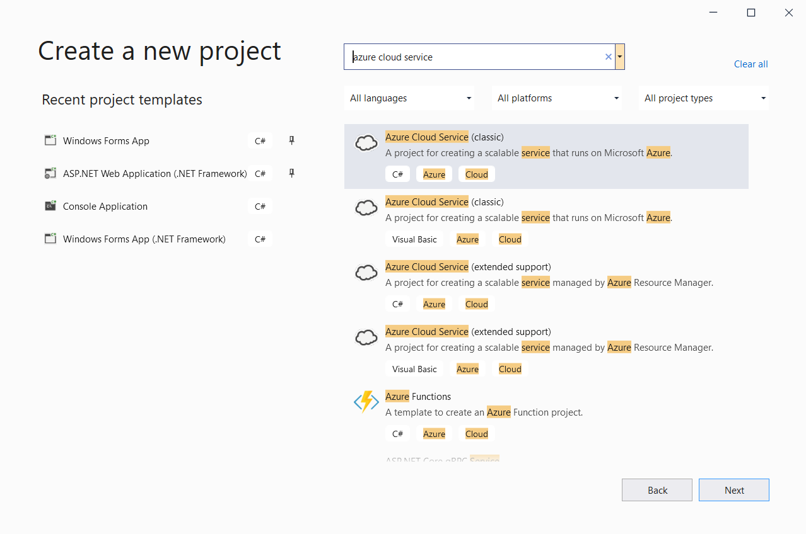

* In above window, choose Language as C#, Platform as Azure, Project as Cloud
* Then select Azure Cloud Service(classic) option

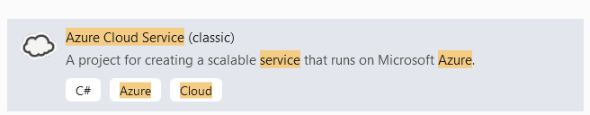

Click Next

Configure project window will appear

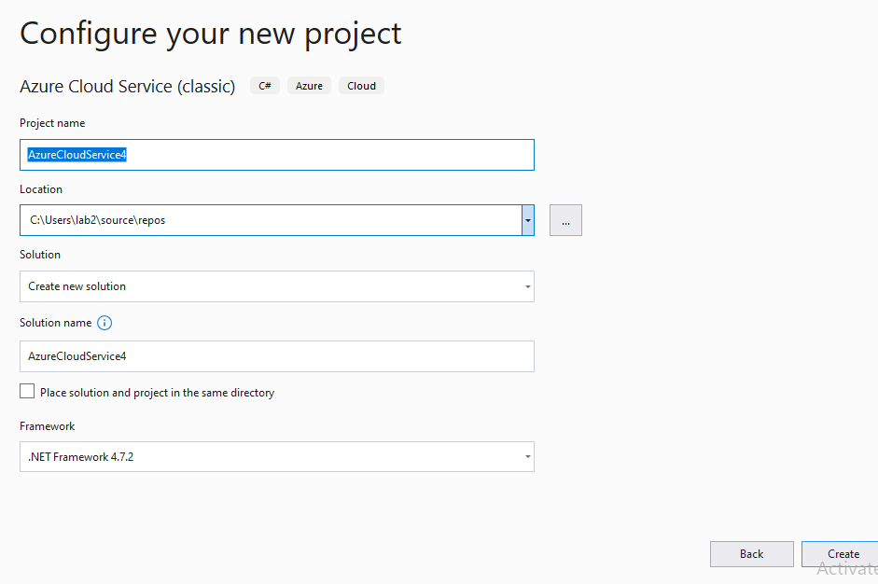

Enter Project name(AzureCloudService1), then click on Create button.

New Microsoft Azure Cloud Service(Classic) window will appear as below. Select Visual C# -> ASP.net Web Role.

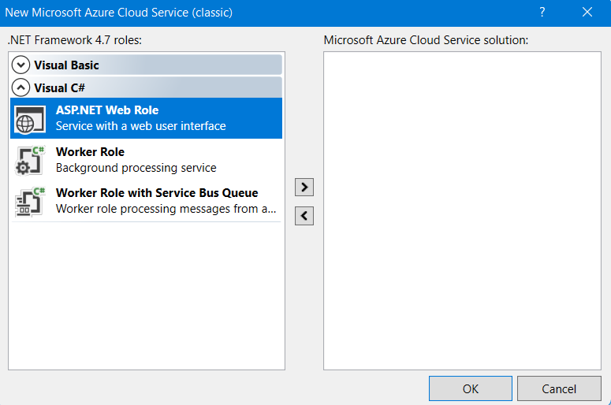

Click on > button for add webrole to solution. Below window will appear.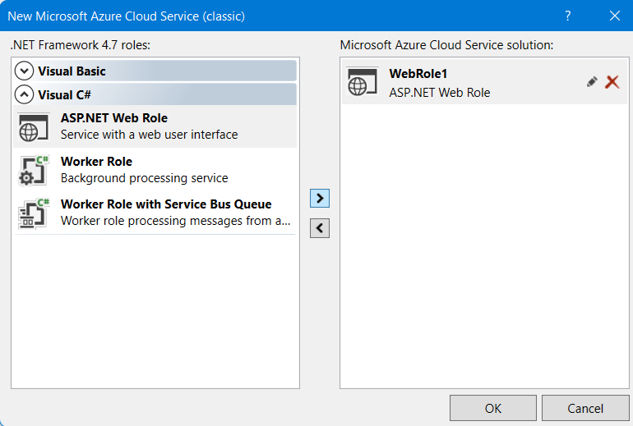

• Click on OK button

• Below window will appear

• Select Empty Option for creating empty project template and then click on Create Button. Below window will appear.

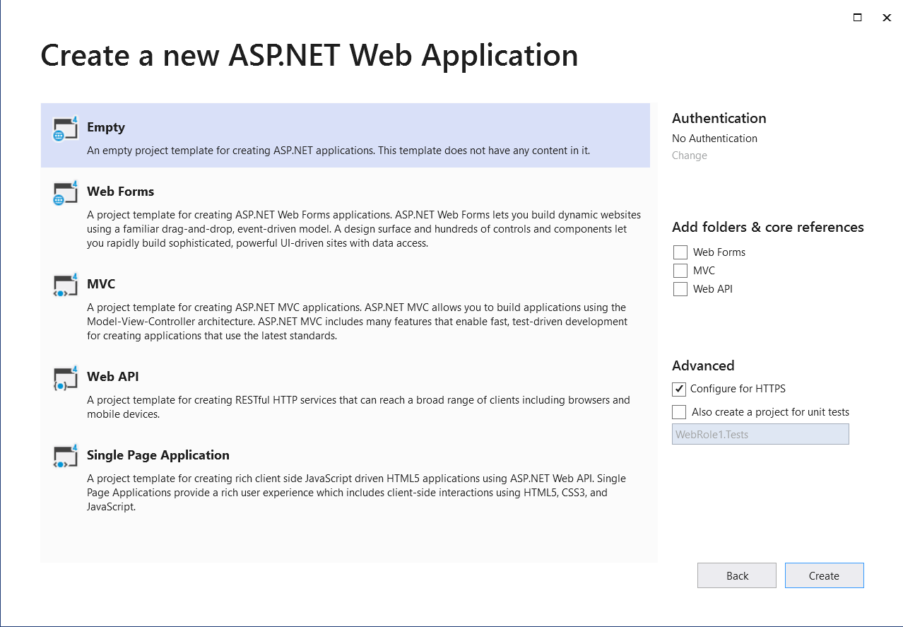

Right Click on WebRole1 in Solution Explorer Window.

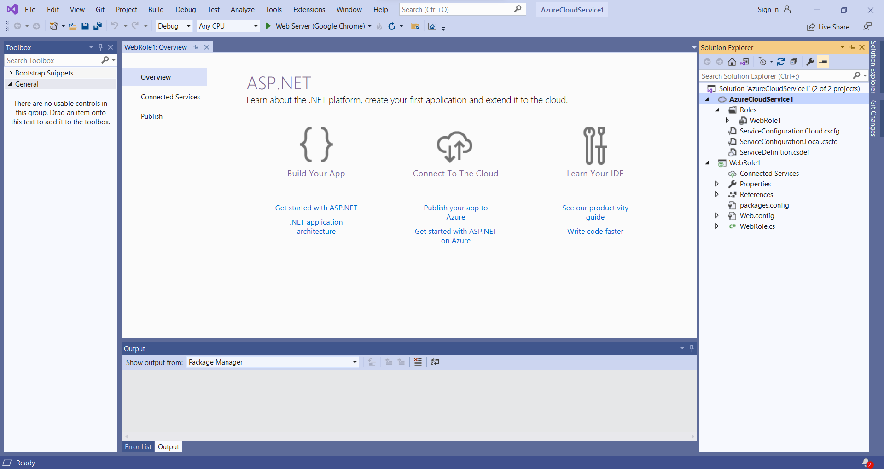

Then click on Add Button and Select Web Form

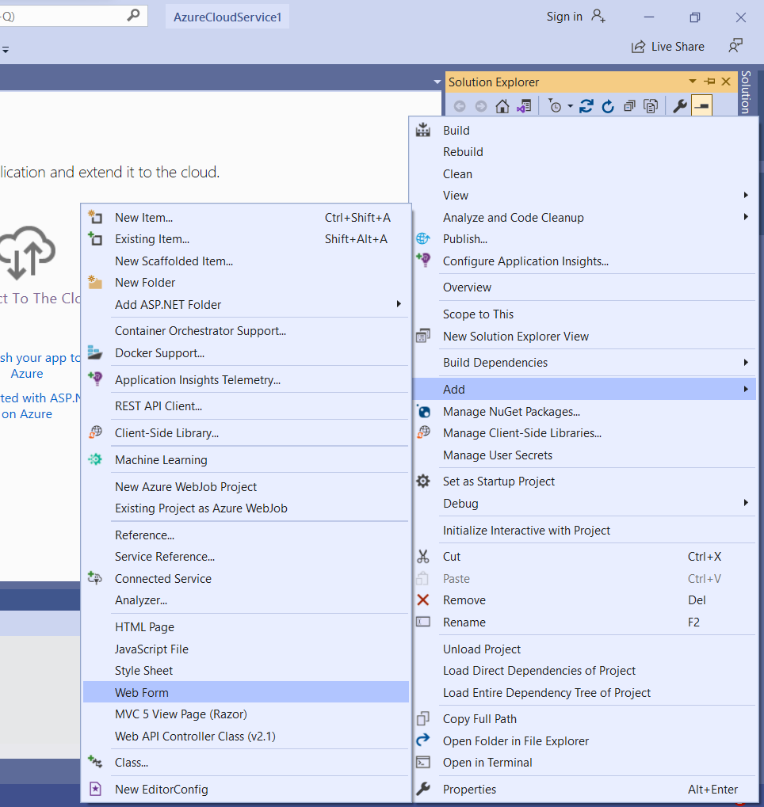

Give Name to Web Form

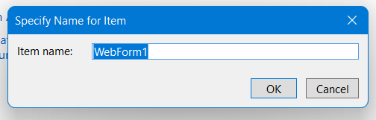

Click on OK Button. Below window will appear.

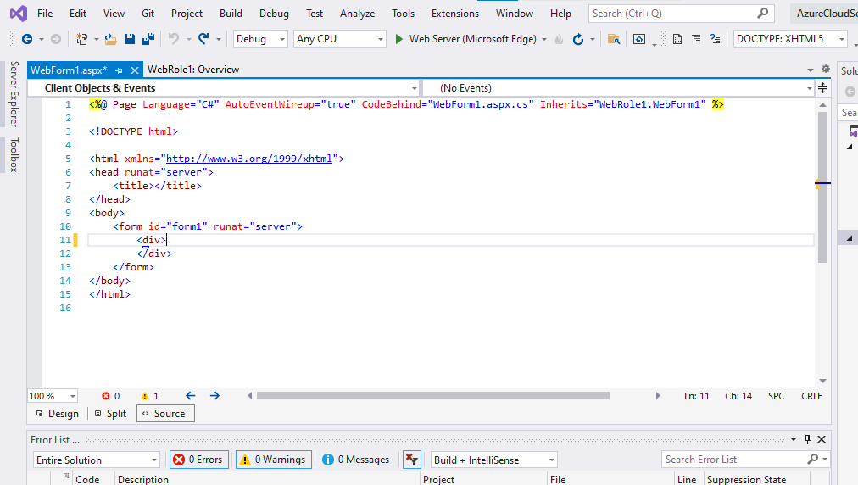

Add the below code in web form you have created

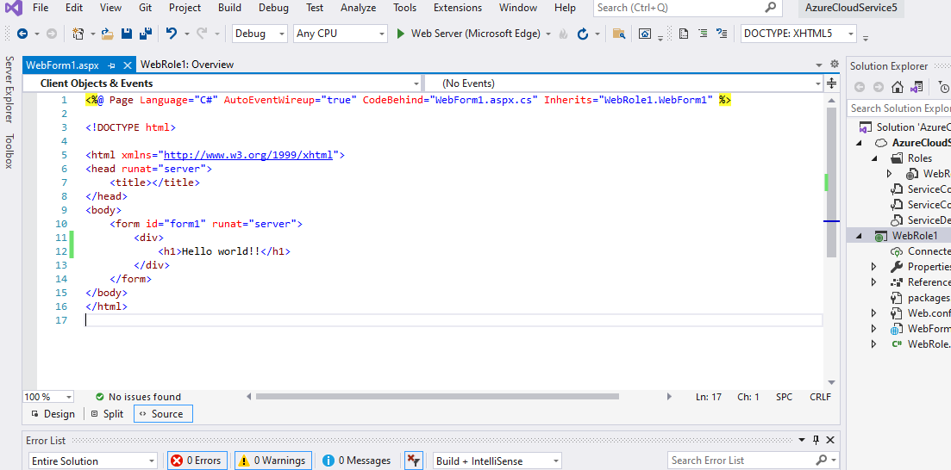

<%@ Page Language="C#" AutoEventWireup="true" CodeBehind="WebForm1.aspx.cs" Inherits="WebRole1.WebForm1" %>

<!DOCTYPE html>

<html xmlns="http://www.w3.org/1999/xhtml">

<head runat="server">

<title></title>

</head>

<body>

<form id="form1" runat="server">

<div>

<h1>Hello world!!</h1>

</div>

</form>

</body>

</html>

Then click on Debug and Execute Project (click on green arrow)

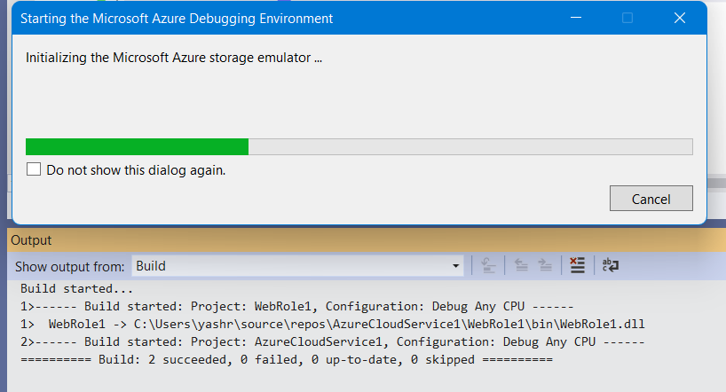

Following is the output:

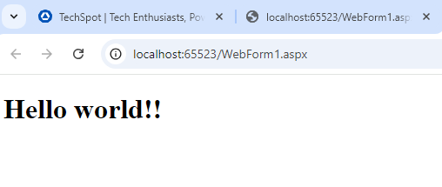

# Practical 12

# Aim:- Develop application for Google App Engine Eclipse IDE

1. **Open Eclipse**:
   * Launch Eclipse IDE.
2. **Go to the Help Menu**:
   * Click on Help in the menu bar.
   * Select Install New Software….

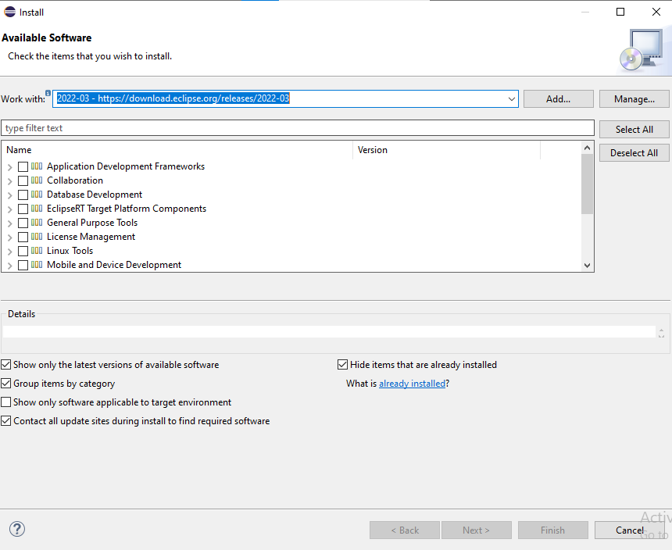

1. **Add New Software**:
   * In the Work with: field, enter the appropriate update site URL for Eclipse WTP (Web Tools Platform).
   * Choose the appropriate software from the list (e.g., "Web XML...").
   * Click on Finish.

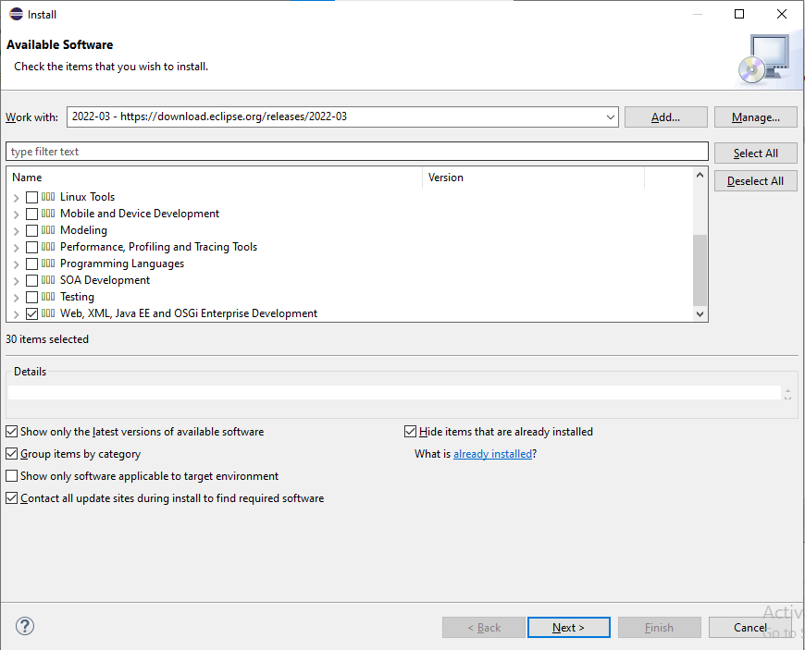

1. **Create a New Server**:
   * Go to the Servers tab in the Eclipse workspace. If you don't see the Servers tab, you can open it by going to Window > Show View > Servers.
   * Right-click in the Servers tab and select New > Server.

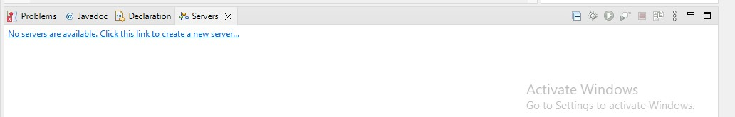

1. **Select Apache Tomcat**:
   * In the New Server wizard, expand the Apache folder.
   * Select Apache Tomcat v9.0 Server.
   * Click Next.

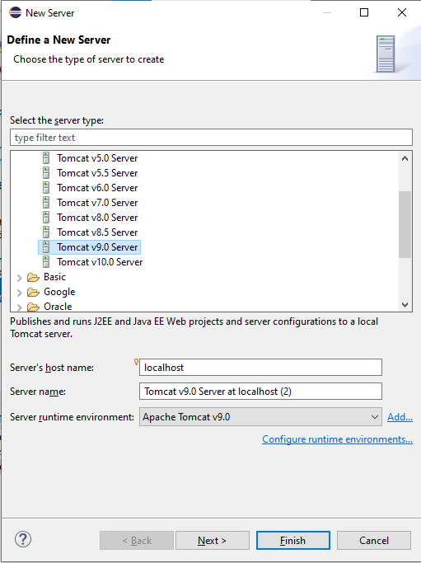

1. **Browse for Tomcat Installation Directory**:
   * In the next window, click Browse….
   * Navigate to the directory where Apache Tomcat is installed.
   * Select the folder and click OK.

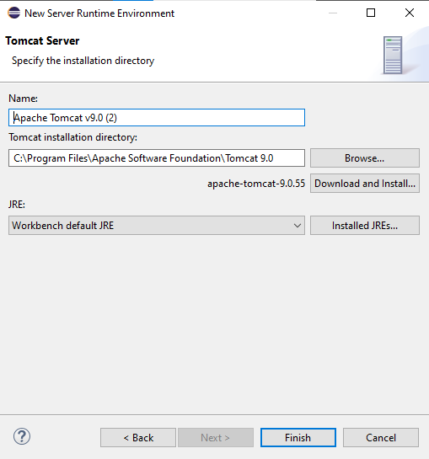

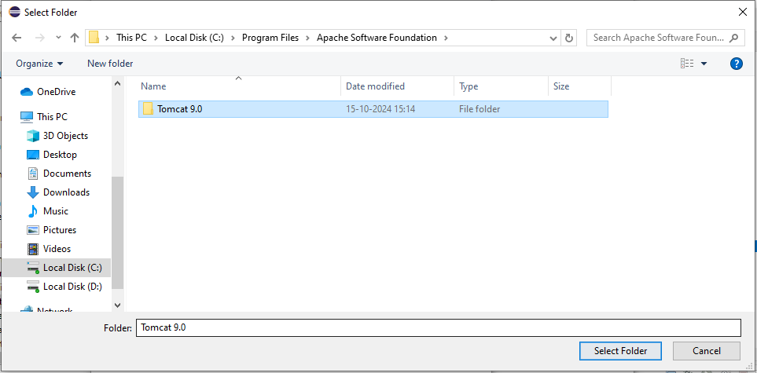

1. **Finish Configuration**:
   * Click Finish to complete the configuration.
2. **Open Eclipse:**
   * **Launch Eclipse IDE.**
3. **Install Google Cloud Tools:**
   * **Go to Help in the menu bar.**
   * **Select Eclipse Marketplace.**
   * **In the search bar, type Google Cloud Tools and select the appropriate version (e.g., 1.8.4).**
   * **Install the tools by selecting all required checkboxes.**
   * **Restart Eclipse after the installation is complete.**

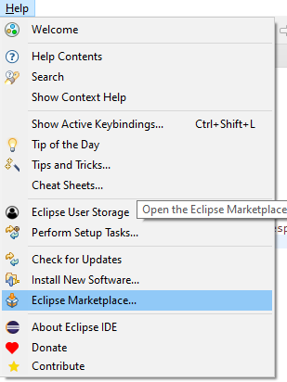 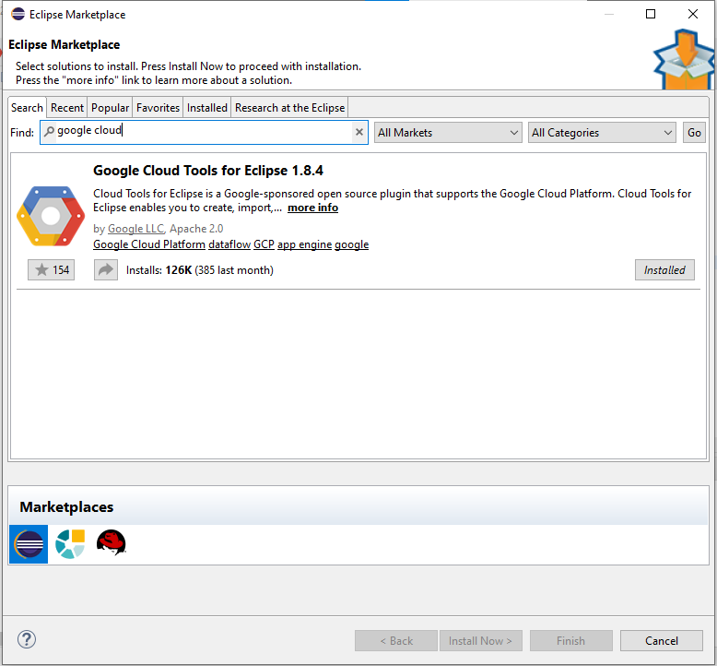

1. **Create a Google Cloud Platform Project:**
   * **Go to File > New > Other….**
   * **Select Google Cloud Platform > Google Cloud Platform Standard Project.**
   * **Click Next.**

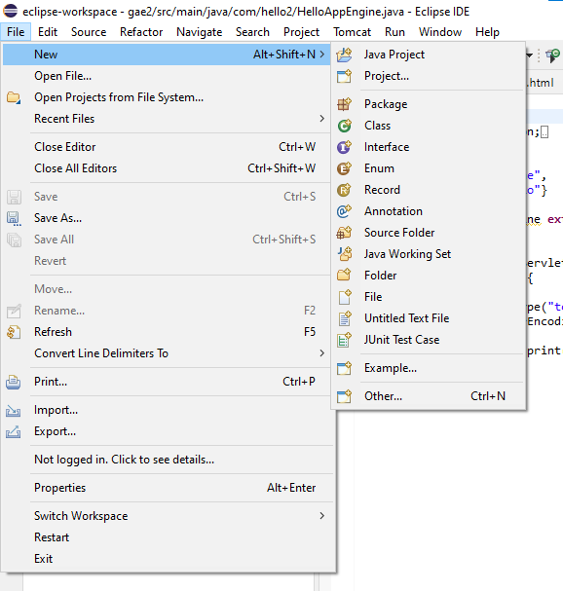 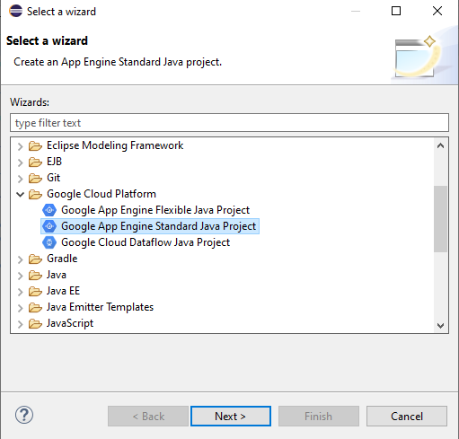

1. **Configure the Project:**
   * **Give your project a name and specify the Java package.**
   * **Select the App Engine API.**
   * **Click Finish to create the project.**

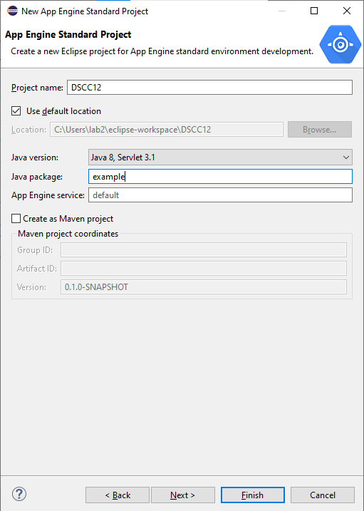 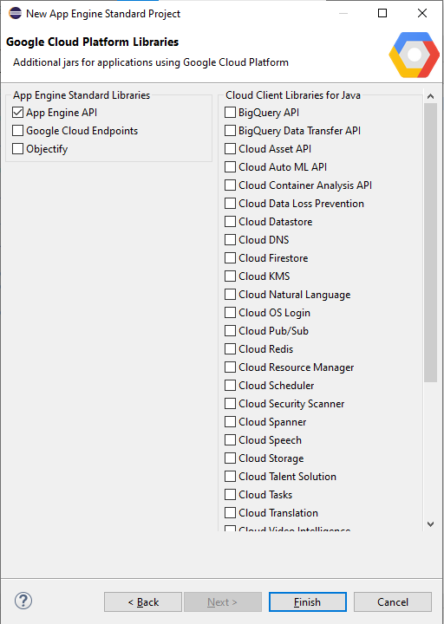

1. **Set Up Google Cloud SDK:**
   * **Go to Window > Preferences.**
   * **Select Google Cloud Tools.**
   * **Click on Choose SDK… and follow the prompts to set up the SDK.**

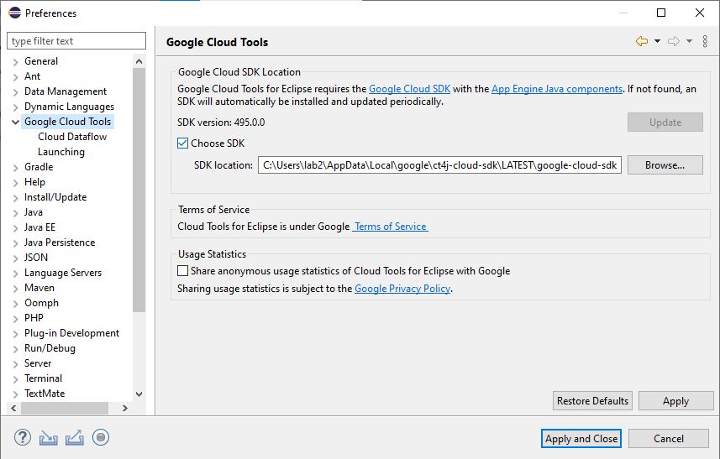

1. **Configure Project Build Path:**
   * **Right-click on your project in the Project Explorer.**
   * **Select Properties.**
   * **Go to Java Build Path.**
   * **Click on Add Library….**
   * **Select Server Runtime and choose Apache Tomcat.**
   * **Click Apply and Close.**

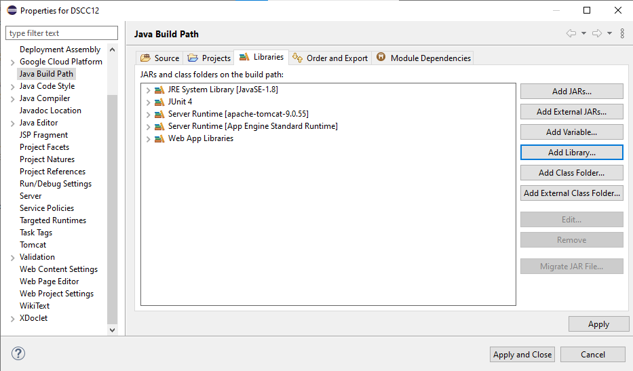

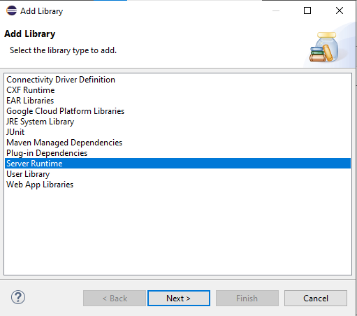

1. **Run on Server:**
   * **Right-click on your project.**
   * **Select Run As > Run on Server.**
   * **Choose Apache Tomcat v9.0 Server and follow the prompts to deploy your project.**

